List of existing clients
S no | Client Name | Logo | Remarks
1. | SV Infra Holding Ltd | 
2 | SRI Sravanthi Infra Projects |  | Requested from client
3 | United Elysium |  | -do-
4 | One Internet Pvt Limited | 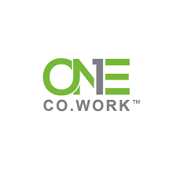
5 | SV Legacy | 
6 | HatsOff Helicopter Training | 
7 | Modenik Lifestyle Pvt Ltd | 
8 | DS-Max Sangam Pvt Ltd | 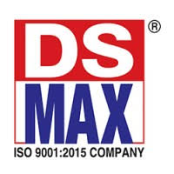
9 | QUIN Bay Technologies | 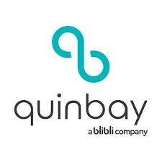
10 | Eeshanya solutions Limited - UK | 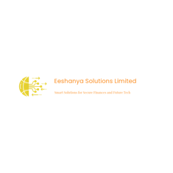
11 | C3S Ltd - UK |  | NA
12 | CommandHQ | 
13 | BeeHive Co-Working Spaces | 

